CutOut to CommandStation-EX for RailCom

DCC frames are generated by the RMT module of the ESP32.
An interrupt occurs at the end of the frame transmission.

Frame looping and interrupt position.
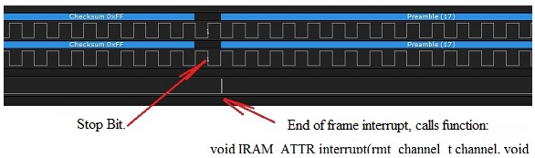

Let's replace the first preamble data with a CutOut data, i.e. a low level of 29µs then a high level of 459µs. (TCE max 488µs – TCS 29µs)

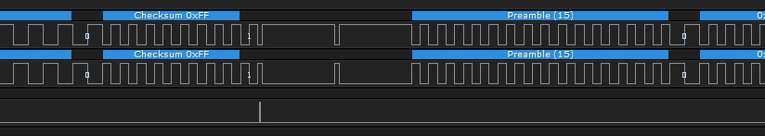

Error, CutOut is sent twice!
Information taken, it is a bug in the IDF.
In Loop mode with interruption, the first bit is sent twice!
Expressif will make a fix but when!, in the meantime what to do?

CutOut twice as short? (Low level 29µs, High level 215µs?)
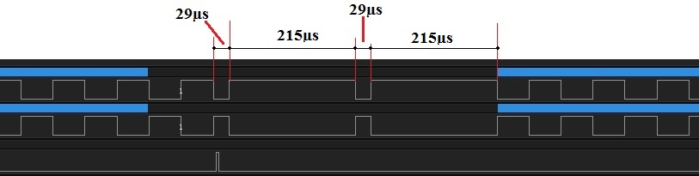

We could thus obtain a low level of 29µs and a high level of 215 +29 + 215 = 459µs.
On condition of correctly positioning the 29µs in the middle!

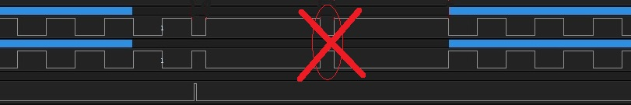

Signal shaping.

During CutOut, signals must be at high levels.
Using a timer in scheduler mode activated by the end-of-frame interrupt.

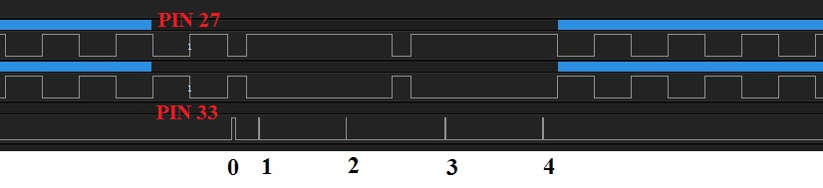

Chronology of events.

0) End of frame interrupt. Disconnect pin 33 of the RMT module, keep it high, activate the Timer in loop. (160µs)
1) Nothing.
2) Disconnect pin 27 of the RMT module, keep it high.
3) Reconnect pins 27 and 33 to the RMT module (inverse true)
4) Reconnect pin 33 to the RMT module (inverse false), stop the Timer.

Result, a perfect CutOut. 29µs low, 459µs high and a 15-bit preamble.

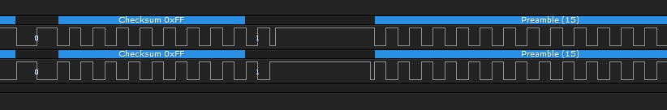

lebelge2@yahoo.fr

